## Practical 2B: Forms Creation

## Preparation:

Read the **Basic Guide** section of <https://developer.mozilla.org/en-US/docs/Learn/HTML/Forms>

Review lecture notes and examples given in the lecture.

## Part A – Activity 1

Download the following files:

Formprocessor.html

Formprocessor2.html

Create a **storyform.html** with the following content and save it in the same folder as the downloaded files:

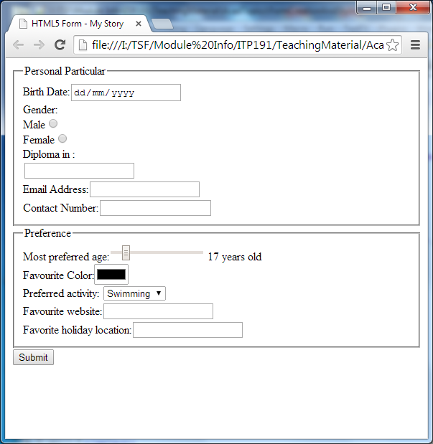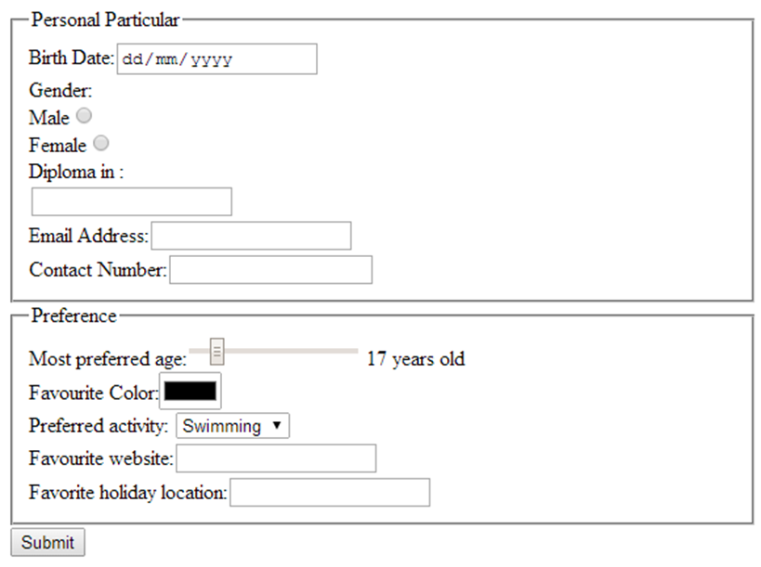

|  |  |  |  |
| --- | --- | --- | --- |
| **Field/Label** | **Name** | **Other requirements** | **Validation** |
| Birth Date | bdate |  | Mandatory, Default by type |
| Gender(Male, Female) | gender | Value for male is boy, for female is girl | Mandatory, Default by type |
| Diploma in | diploma | With datalist. List contains All diplomas in SIT | Mandatory |
| Email | email |  | Mandatory, Default by type |
| Contact | contact | When hover over the field this  should appear | Mandatory, 8 digits telephone number |
| Most Preferred Age | age | From 1 to 120. Default is 17 | Mandatory |
| Favourite Color | color |  | Mandatory |
| Preferred Activity | activity | Swimming is the default selected activity | Mandatory |
| Favourite Website | website | Use placeholder to indicate input format. E.g. | Mandatory |
| Favourite Holiday Location | location |  | Mandatory |

Display the form, fill in the form and press submit. Write down the URL displayed after the submit button is pressed.

http://10.18.1.232:5500/W3/FormProcessor.html?bdate=2021-03-31&gender=boy&diploma=Common+ICT+Programme&email=declanisaackuok%40gmail.com&contact=81131338&age=17&color=%23000000&activity=Swimming&website=www&location=Great+Elroe+Labyrinth

Briefly explain the content of URL after the question mark (?).

The content of the URL after the question mark is the form information.

For specifics, let’s take an example: “gender=boy”. The first part before the equality sign is the name of the input (name attribute). The second part after the equality sign is the contents of the filled form. After that there would be an ampersand (&) to signify the next portion of the form

There are 2 methods to send the form. Which are the 2 methods? By default which method has been used to submit the form that you created? How can you change the method?

The default is the “GET” method. You can change the method by doing <form method=”post”> which changes the default method from get to post

Add another attribute to the form – **action** as below:

**<form method="get" action="FormProcessor.html">**

What is the usage of this attribute?

The usage of the action attribute is to tell the program to send the form contents to that specific location. In which case it is FormProcessor.html

Display the form, fill in the form and press submit. What do you see?

# Your form has been submitted!

## You entered the following data:

bdate=2021-03-31  
gender=boy  
diploma=Common ICT Programme  
email=declanisaackuok@gmail.com  
contact=81131338  
age=17  
color=#000000  
activity=Swimming  
website=www  
location=Great Elroe Labyrinth

Modify the form such that it sends the form data to **FormProcessor2.html**. Upon submission of the form, you should get a short write up about data entered. If you are not getting it, you might have not created the form based on the requirements stated. Write down one thing you have learnt from this step.

The default is the “GET” method. You can change the method by doing <form method=”post”> which changes the default method from get to post

## Check Points

## Here are a few points to remember:

## Point 1: HTML <input> name attribute

The name attribute specifies the name of an <input> element. It is very important to know that only form elements with a name attribute will have their values passed when submitting a form.

Also, when dealing with a group of radio buttons or checkboxes, the name given to each <input> within the same group must be the same.

## Point 2: HTML <input> value attribute

For input type like “text” that requires users to **enter** their input, there’s no need to specify the value attribute unless you want to specify a default value.

On the other hand, for input types like “radio” or “checkbox” that requires users to **select** one or more options, it is important to include the value attribute indicating the users’ selection.

## Point 3: HTML <input> action & method attribute

When a form is submitted, the data entered by the user is sent to another document or web server for processing. The action attribute specifies the name of this location.

<form name="input" action="processform.html" method="get">

Username:

<input type="text" name="user"/>

<input type="submit" value="Submit"/>

</form>

There are two different kinds of methods: “get” and “post”.

When the method “post” is used, the user inputs will be sent to web server as name-value pairs in a data file (HTTP post transaction). If there are more than one piece of data, the **&** sign is used to separate them. The name and value of the name-value pair comes from the name and value (refer to point 2) attribute of the <input> element.

When the method “get” is used, the user inputs are sent as URL variables, appended as name-value pairs to the end of the URL indicated in the action attribute. Similarly, if there are more than one piece of data, the **&** sign is used to separate them. As seen below, the method “get” is clearly not a secure way to send confidential data and should be avoided when dealing with such data. Such string is also known as **query string**.

## processform.html?user=john&password=12345

## Reflection

## What have you learnt?

I have learnt that “value” has different functions in different tags. In the meanwhile I have learnt of the attribute “pattern” where it is kind of like a regex (Regular Expressions) which is very useful if one is going to input a phone number. I have learnt that post sends name-value pairs to the web server and it is not a safe way to send confidential data.

## Which part you need more clarification/help ?

Not much